Course Name | ITD 2313 – Script Programming
Instructor | Rene Hurst
Student Name | Pete Fuentez
Due date | Sep 29 by 11:59 pm
Grade | Put grade earned here
Grading Comments | Put instructor comments here

Week 5 - Textbook Exercises
The boolean type, Comparisons, and Boolean expressions
Page 64
- At the top of the page, you will find a code example block with several boolean expressions to enter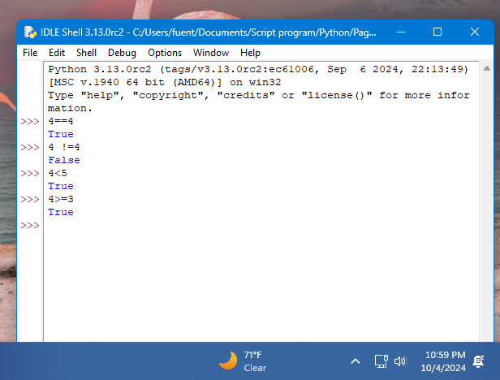

if-else statements
Page 65
- About half the way down on the page, you will find a code example block starting with import math. 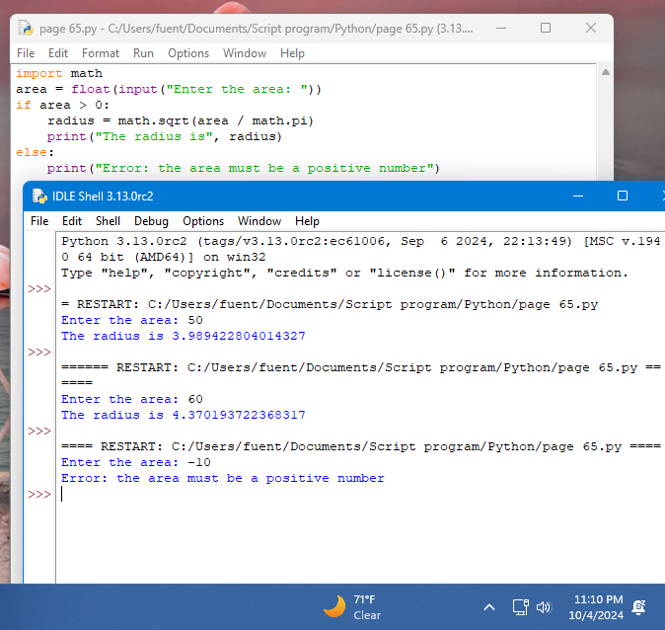
- You do not type in the if template as part of this exercise.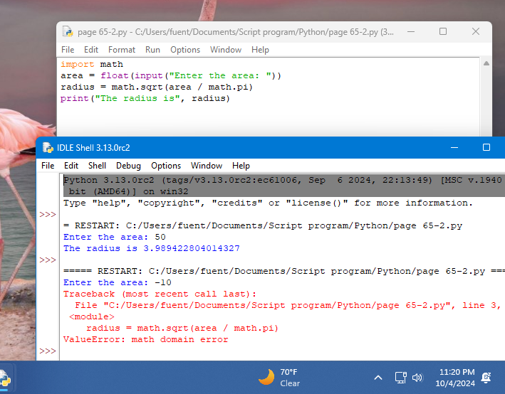
- At the top of page 66t is your first code example block for this page 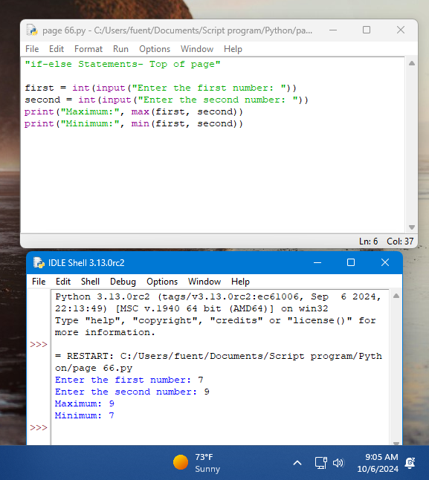
- The second and final for the page hits at about the half way down on the page and covers min/max functionality. 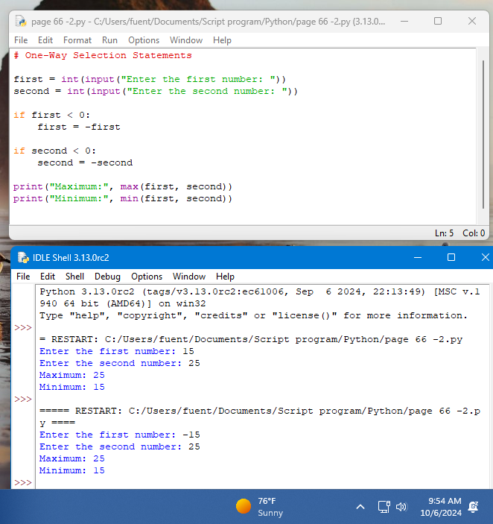

Multi-way if statements
Page 67
- The code example blocks is half way down the page.
- The second code example block is in the middle of the page. 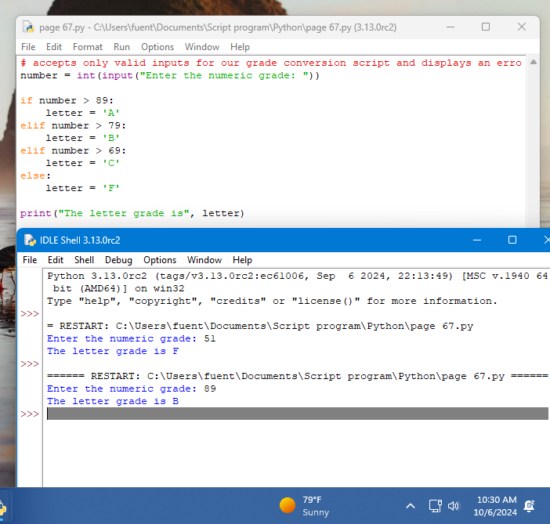

Logical Operators and Compound Boolean expressions
Page 68
- The code example block is about 1/2 the way down on the page.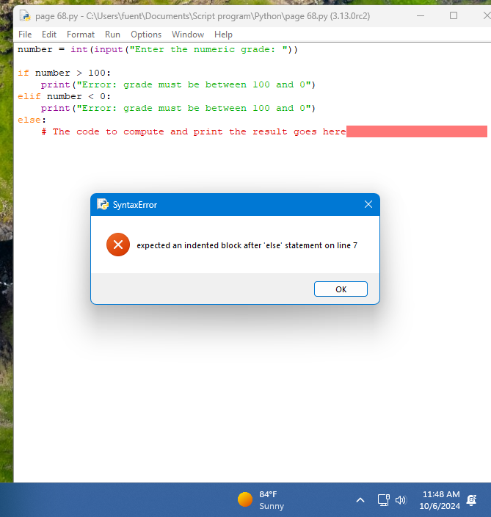
- The second code example block is about 3/4 way down.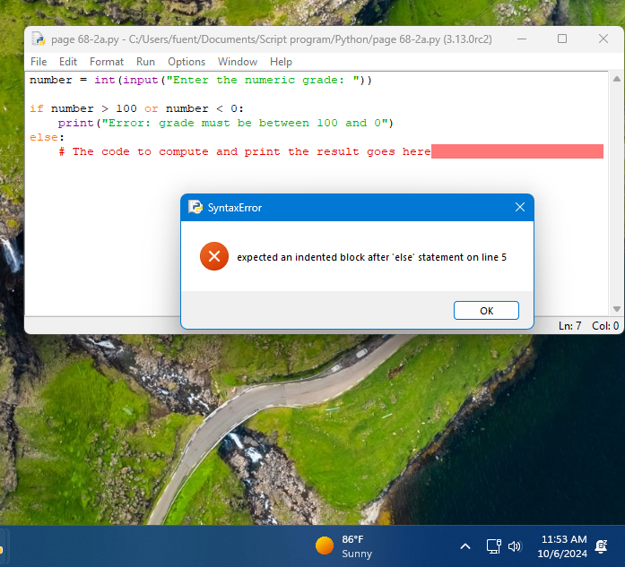

- Notice in this example that there is a single line comment saying that the compute and print code goes here. I would like you to replace that comment with the code the computers the Square of the number they input and prints out the result to the user. 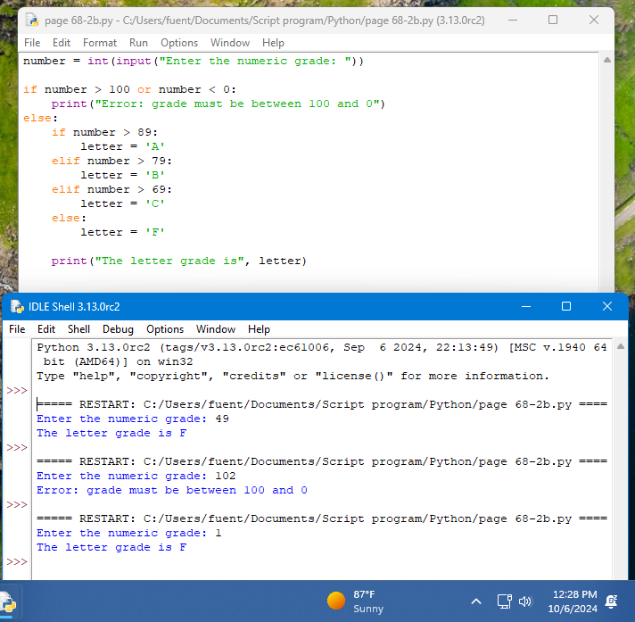
- The third code example block is at the bottom the page.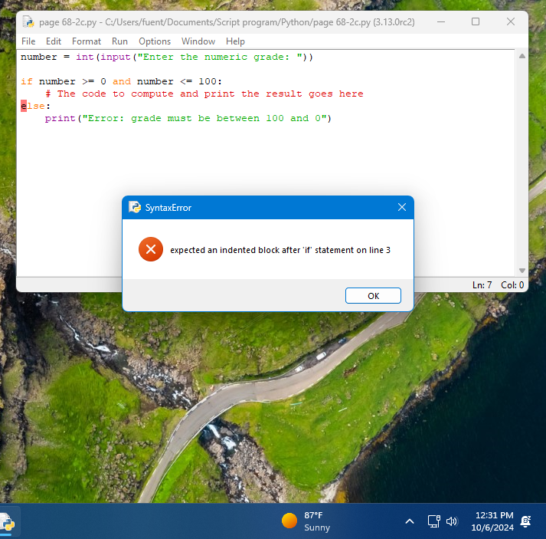

- It also has a single line comment that will need to be replaced with code the computes and displays the square of the number input.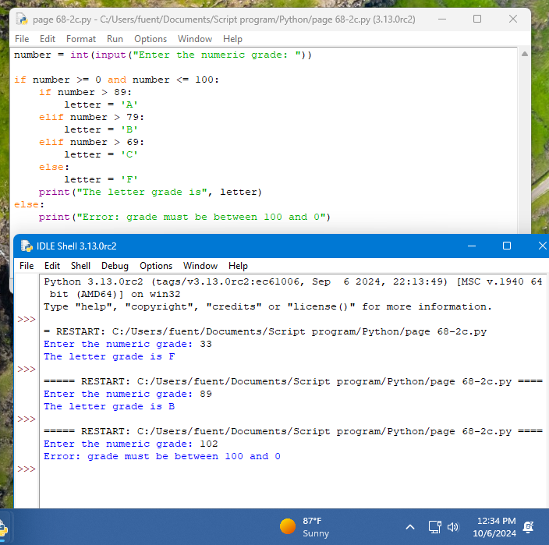

Page 69
- The first code example block on the page is at the bottom on the page.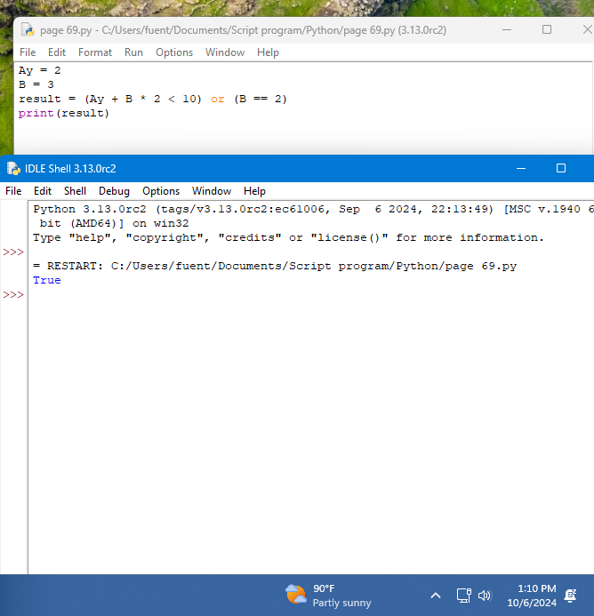

page 70
- The code example block is on the top of the page. 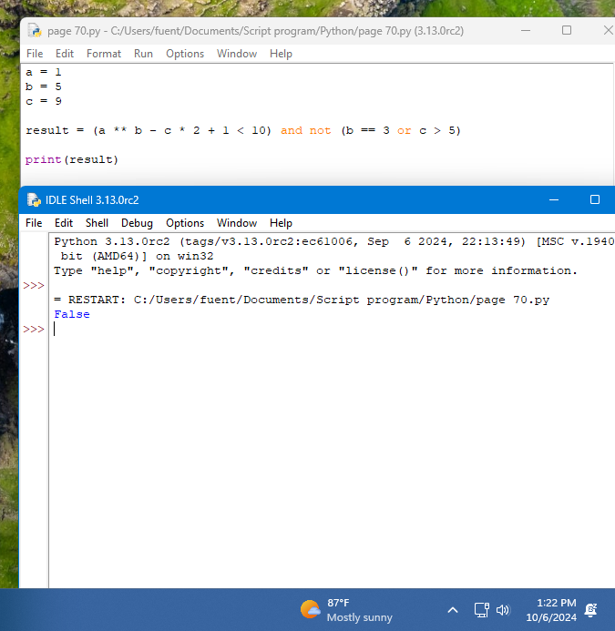

Short Circuit evaluation
Page 70
The first code example block is about 3/4 the way down the page.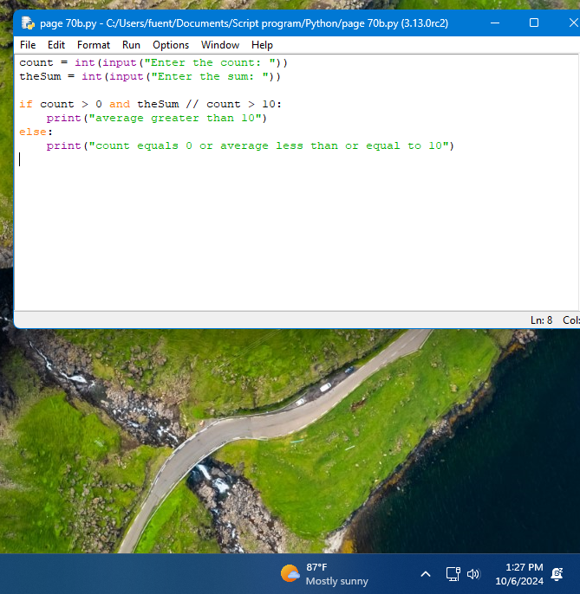

Show how it runs with a couple of different values.
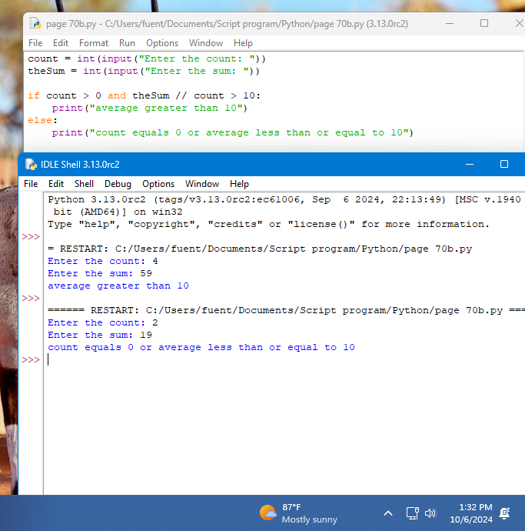
Count needs to be set to 0 at least 1 time.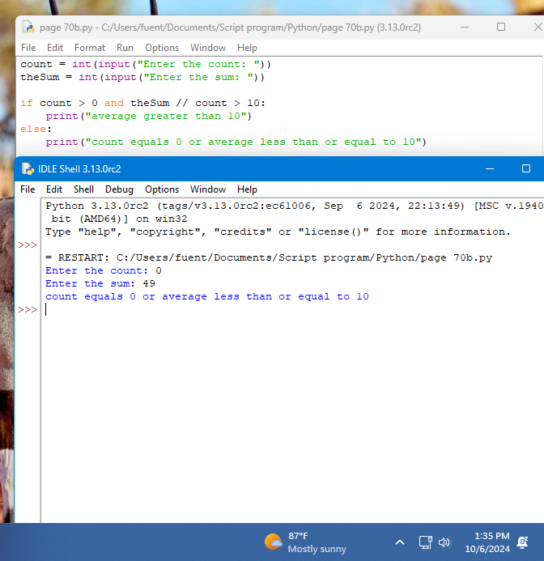

Conditional Iteration: The while Loop
The structure and behavior of a while loop
Page 73
- At the top of the page is the code example block on the page. When you execute it, be sure to use the same numbers shown in the text to get the same answer as in the text.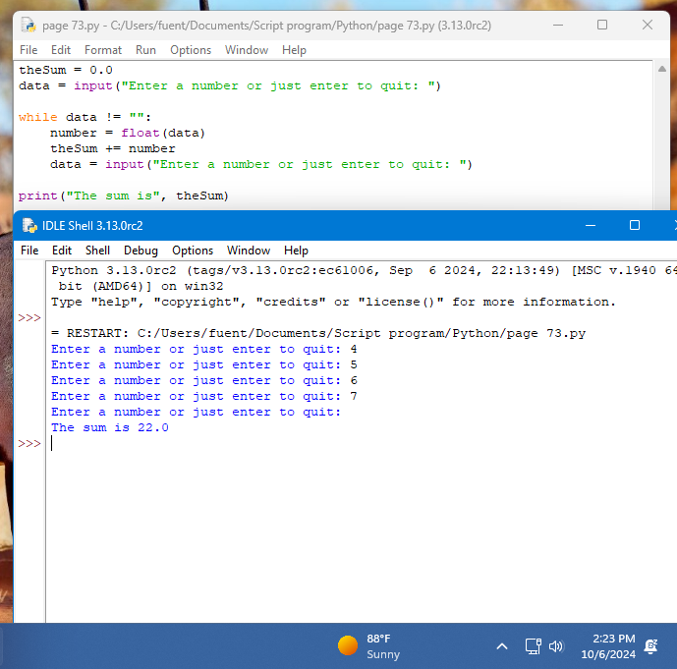

Count control with a while loop
Page 73
- About 2/3 mark on the page, there are two while loop code examples in that block. The issue is that they do not show you the results. Be sure you capture the results.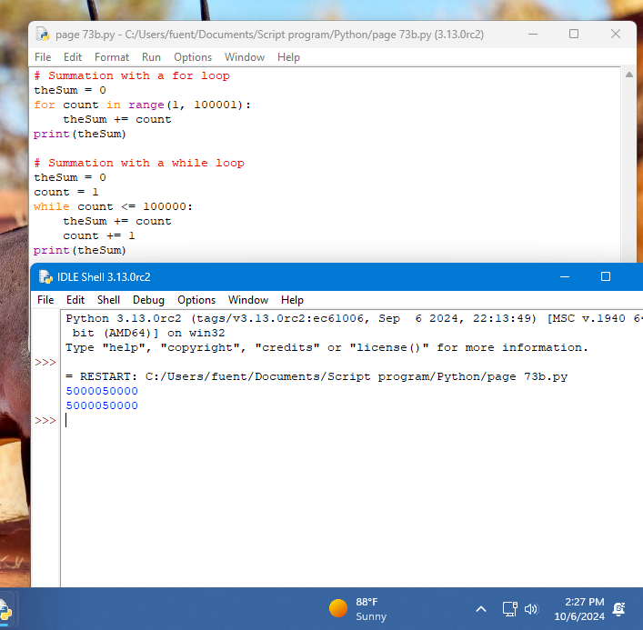
- At the top of page 74, they do it again and show you two loops without showing the output. Enter both the loops in the code example block and catch the output for them.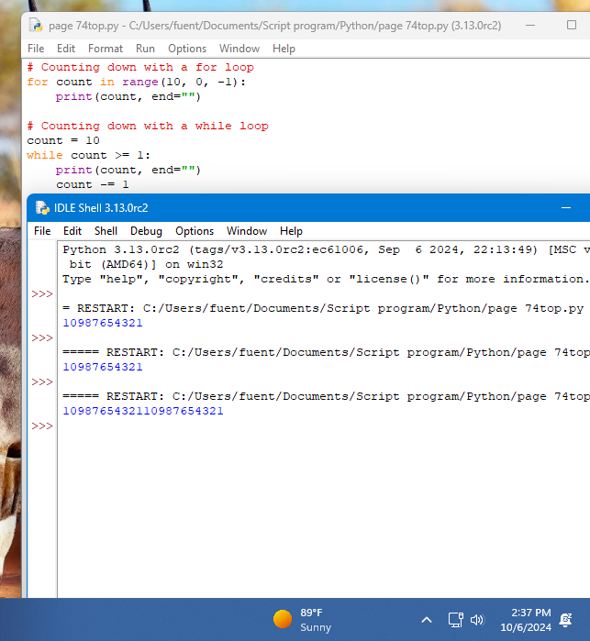

The while true loop and the break statement
Page 74
- The first of the code example blocks is about 1/2 down the page. They do now show you the results but you will need to catch some portion of the results in a screen shot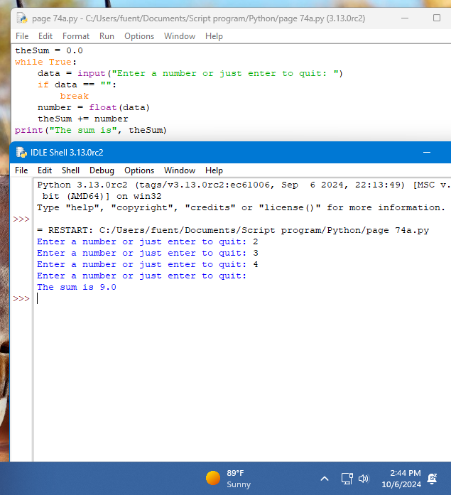
- The second code example is 3/4 the page. A sample run is show so duplicate that sample run when you do the screen shot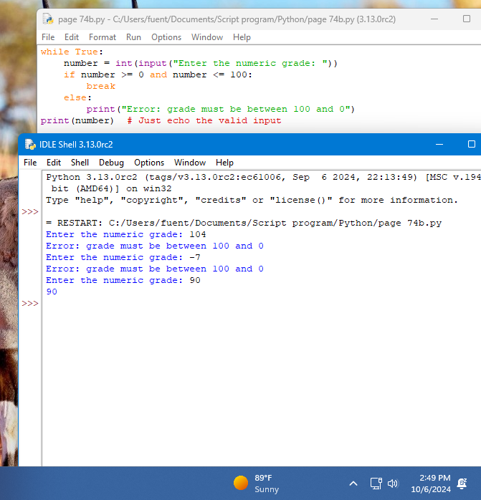
- At the very bottom is the last of the three code example blocks for this page. It does spill onto the next page. Be sure to grab some output your screen shot.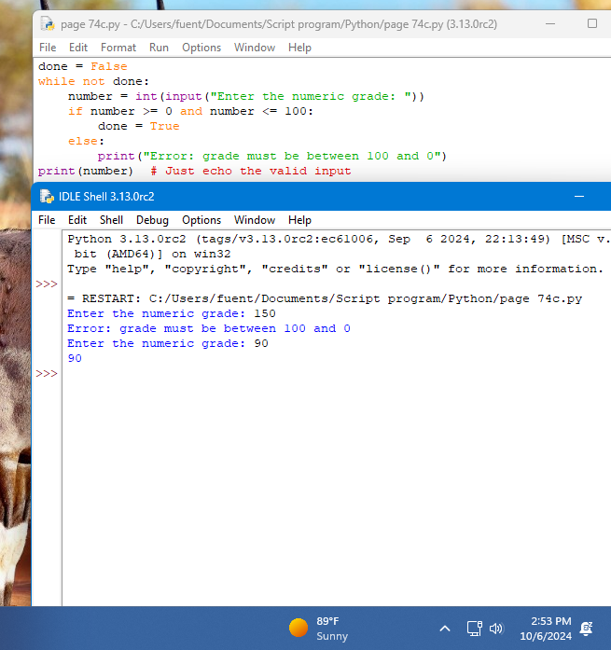

Random Numbers
Page 75
- Ever wanted to make you own dice roller? Well here you go, using this code example block in the 3/4 of the page will let you make one. Your output most likely will different since the rolls are supposed to be random.